Humanitarian Programme Officer
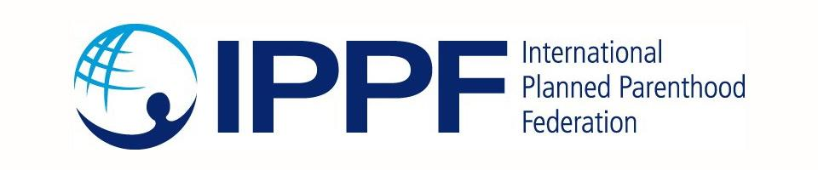
Job Title: Senior Humanitarian Programme Officer (Ref: HPO1)
Supervisor: SPRINT Programme Manager
Division: Humanitarian Programme
Type of Appointment: local hire position (Malaysian nationality only)
Location: Kuala Lumpur, Malaysia
Grade: D

International Planned Parenthood Federation (IPPF)
Join us to defend the sexual and reproductive health rights of all people
1. THE ORGANISATION
The International Planned Parenthood Federation (IPPF) is a leading global service provider and advocate of sexual and reproductive health and rights for all. A federation of 152 Member Associations (MAs), IPPF works in 172 countries and maintains more than 45,000 service delivery points worldwide. IPPF aims to ensure that all people are free to make choices about their sexuality and well-being, in a world free of discrimination.
2. THE ROLE
The Humanitarian Programme team was created in early 2017 to ensure that IPPF has a well-resourced global humanitarian team of technical advisors who provide support to IPPF’s Member Associations. IPPF-SPRINT initiative is a grant funded by the Australian government that aims to ensure access to life-saving Sexual and Reproductive Health (SRH) services during emergencies mainly in the Asia-Pacific region. SPRINT is managed under the IPPF global humanitarian programme. The function of this role is to support the Humanitarian Programme, with focus on supporting SPRINT MAs.
The role will report to the SPRINT Manager, Humanitarian Team and work closely with the technical team, as well as the Humanitarian Director and Deputy Humanitarian Director. The post holder will also engage closely with the program, technical and operation staff in the regional offices.
3. KEY TASKS
3.1 Programme Management Support (40%)
- Support the humanitarian team in the development and execution of humanitarian programme and country-level humanitarian workplans.
- Review and edit project reports from countries as requested with guidance from the SPRINT Manager including emergency response reports, donor reports and external publications.
- Assist in programme management related tasks on SPRINT, Stream 3 and other restricted funding projects.
- Review and process sub-grant contracts to country programmes (Member Associations) and emergency response funding agreements for humanitarian programme activities in collaboration with programmes and finance.
  - Emergency preparedness support (30%)
- Coordinate support to MAs for the development and review of the emergency response/preparedness plans, simulation exercise, and national-level policy advocacy work on SRH in emergencies.
- Provide support to MAs to develop and manage a national level surge rosters as a focal person with guidance from the Technical Lead.
3.3. Programme Activity Support (10%)
- Support data entry into database and M&E systems including an indicator spreadsheet, and emergency response database.
- Assist the humanitarian programme team members with development of external and internal reports, web content, presentations and technical tools as needed.
- Provide support on developing training materials, presentations, and facilitation of trainings under the supervision of relevant advisors.
- Assist with the tracking and collection of deliverables (reports etc.).
3.4. Knowledge Management (10%)
- Lead on knowledge management for the humanitarian team including supporting increased knowledge sharing, retention and learning among IPPF staff and Member Associations (MAs).
- Manage the Humanitarian Programme Team platform and the humanitarian team’s internal SharePoint filing system.
3.5 Administrative Support (10%)
- Organize team meetings, take meeting notes, and send out calendar invites
- Provide logistical and administrative assistance in the planning and execution of humanitarian programme workshops, meetings, and trainings
PERSON SPECIFICATION, QUALIFICATIONS, EXPERIENCE & SKILLS
- University qualification (required), and post graduate degree (desired), preferably in international development, public health or a related field.
- At least 3 years of experience working for a non-governmental (humanitarian) organisation.
- Experience in supporting programme staff in NGO (desired)
- Knowledge of sexual and reproductive health care (desired)
- Exposure to humanitarian or disaster relief work (desired)
- Fluency in written and spoken English and Bahasa Malaysia (required)
- Good analytical and problem-solving skills, including the ability to think creatively
- Strong attention to detail and follow-up
- Excellent organizational skills: the ability to multi-task, learn quickly, and work independently and productively in a fast-paced and detail-oriented environment
- Excellent interpersonal and communication skills: the ability to effectively liaise with and motivate a variety of people in a multi-cultural environment
- Good computer skills: MS Word, Excel, and Power Point.
- Supportive of a woman’s right to choose and to have access to safe abortion services.
- Willing to travel up to 15% of the time.
- Commitment to stay in the post until December 2024.

